Multiplication and Division of Fractions
5.NF.B Conceptual Understanding Mini-Assessment by Student Achievement Partners

OVERVIEW
This mini-assessment is designed to illustrate cluster 5.NF.B, which sets an expectation for students to apply and extend previous understandings of multiplication and division to multiply and divide fractions. This mini-assessment is designed for teachers to use either in the classroom, for self-learning, or in professional development settings to:
- Evaluate students’ understanding of 5.NF.B in order to prepare to teach this material or to check for student ability to demonstrate understanding and apply these concepts;
- Gain knowledge about assessing conceptual understanding of fraction multiplication and division;
- Illustrate CCR-aligned assessment problems;
- Illustrate best practices for writing tasks that allow access for all learners; and
- Support mathematical language acquisition by offering specific guidance.

MAKING THE SHIFTS
This mini-assessment attends to focus as it addresses multiplication and division of fractions, which are at the heart of the grade 5 standards and a key component of the Major Work of the Grade. It addresses coherence across grades by extending grade 4 understanding of multiplication of fractions by whole numbers to grade 5 understanding of multiplication of fractions or whole numbers by fractions. Cluster 5.NF.B and this mini-assessment target conceptual understanding, one of the three elements of rigor.

A CLOSER LOOK
5.NF.B. Apply and extend previous understanding of multiplication and division to multiply and divide fractions.
Students begin thinking about the meaning of fractions and fraction equivalence in grade 3, and build on those understandings in grade 4 by beginning to perform operations with fractions. In grade 5, students use previous understanding of multiplication and division, along with understanding from the Number and Operations—Fractions domain, to multiply and divide fractions. Key developments in grade 5 include connecting fractions to division (5.NF.B.3), multiplying a whole number or a fraction by a fraction (5.NF.B.4), and understanding multiplication as scaling (5.NF.B.5) in preparation for ratios and proportional relationships, which is introduced in grade 6. Students extend their understanding of division to divide unit fractions by whole numbers and to divide whole numbers by unit fractions (5.NF.B.7).

The questions on this mini-assessment address the conceptual understanding described in 5.NF.B mostly using short questions that are either free of context or have little context. In grade 5, to show conceptual understanding students may be asked to explain their reasoning, critique the reasoning of others, or complete short contextual problems to assess underlying concepts. The short contextual problems help students attach meaning to the operations and make sense of division problems. See the annotations in the answer key for discussion of how some of the questions assess conceptual understanding.

SUPPORT FOR ENGLISH LANGUAGE LEARNERS
This lesson was designed to include specific features that support access for all students and align to best practice for English Language Learner (ELL) instruction and assessment. Go here to learn more about the research behind these supports. Features that support access in this mini-assessment include:
- Tasks that allow for multi-modal representations, which can deepen understanding of the mathematics and make it easier for students, especially ELLs, to give mathematical explanations.
- Tasks that avoid unnecessarily complex language to allow students, especially ELLs, to access and demonstrate what they know about the mathematics of the assessment.
Prior to this mini-assessment, ensure students have had ample opportunities in instruction to read, write, speak, listen for, and understand the mathematical concepts that are represented by the following terms and concepts:
- expression
- product
- comparison
- area
- square mile
- acres
- number line
- greatest
- least
- fraction
- equal
Students should engage with these terms and concepts in the context of mathematical learning, not as a separate vocabulary study. Students should have access to multi-modal representations of these terms and concepts, including: pictures, diagrams, written explanations, gestures, and sharing of non-examples. These representations will encourage precise language, while prioritizing students’ articulation of concepts. These terms and concepts should be reinforced in teacher instruction, classroom discussion, and student work (for example, through engagement in mathematical routines).
ELLs may need support with the following Tier 2 words found in this mini-assessment:
- place
- point
- create
- true
- order
- diagram
In preparation for giving this mini-assessment, teachers should strive to use these words in context so they become familiar to students. It will be important to offer synonyms, rephrasing, visual cues, and modeling of what these words mean in the specific contexts represented in the items in this mini-assessment. Additionally, teachers may offer students the use of a student-friendly dictionary, or visual glossary to ensure they understand what is being asked of them in each item.
Sketch | 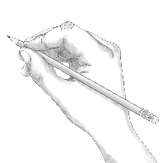
Point | •
Locate | •
An example of a visual glossary for student use.

Name: Date:

- Decide whether the expression in column A or B is larger. Check the correct box for each row.
A | B | Which is larger?
$$\frac{5}{17}×\frac{2}{3}$$ | $$\frac{5}{17}×\frac{3}{2}$$ | A B
$$\frac{27}{25}×36$$ | $$\frac{30}{32}×36$$ | A B
$$\frac{63}{54}$$ | $$\frac{63}{54}×\frac{62}{54}$$ | A B
$$9×\frac{1}{3}$$ | $$\frac{1}{3}$$ | A B

  - Write 11 ÷ 5 as a fraction. _________________

  - Place a point that shows this number on the number line below.
- Write >, =, or < to make each comparison true.
  - $2÷3$ _____ $2÷\frac{1}{3}$
  - $0.2×\frac{1}{4}$ _____ $\frac{2}{10}×\frac{1}{3}$
  - $\frac{1}{6}÷4$ _____ $\frac{1}{6}×\frac{1}{5}$
- Draw a diagram to show $\frac{2}{3}×\frac{3}{4}$.
What is the product of $\frac{2}{3}×\frac{3}{4}$ ?

- One square mile is equal to 640 acres. What is the area, in acres, for the piece of land shown in the diagram below?
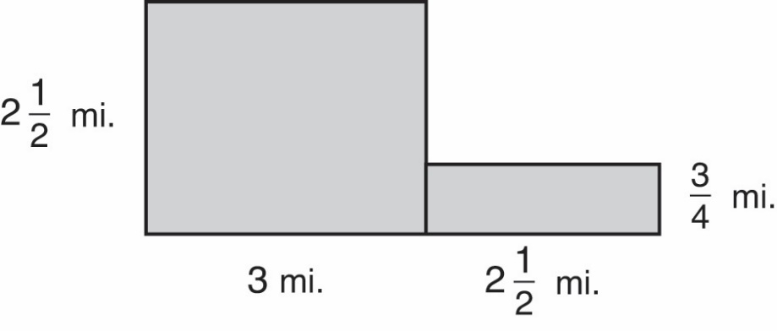

Area = ________ acres
- What is the product of $2\frac{1}{2}×3\frac{3}{4}$ ?
- Place points at $\frac{5}{2}$ and $\frac{1}{3} × \frac{5}{2}$ on the number line below.
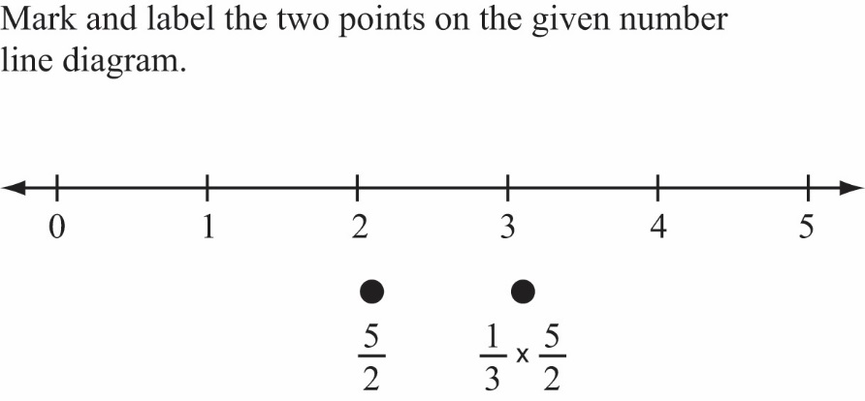

- Order the following numbers from greatest to least.
$\frac{5}{4}×15$ $\frac{4}{3}×10$ $\frac{2}{3}×15$ $\frac{3}{2}×10$
Greatest:

Least:
- Tina is making $\frac{1}{4}$ pound hamburgers. Write an expression, using division, that shows the number of hamburgers she can make with 9 pounds of hamburger meat.

Name: Date:

- Decide whether the expression in column A or B is larger. Check the correct box for each row.

A | B | Which is larger?
$$\frac{5}{17}×\frac{2}{3}$$ | $$\frac{5}{17}×\frac{3}{2}$$ | A B
$$\frac{27}{25}×36$$ | $$\frac{30}{32}×36$$ | A B
$$\frac{63}{54}$$ | $$\frac{63}{54}×\frac{62}{54}$$ | A B
$$9×\frac{1}{3}$$ | $$\frac{1}{3}$$ | A B
The numbers used in these problems are intentionally “messy.” They encourage students to think about the value of the factors being multiplied (whether they are greater or less than 1) and consider the results of multiplying by fractions that are greater or less than one. Students who reason in this way will have a more manageable problem than if they actually compute each product.
In the first comparison, the first factor in column A is multiplied by an expression less than 1 while the same first factor in column B is multiplied by an expression greater than 1. Similarly, in the third comparison, the student should see the same fraction in both columns A and B, but in column B, that fraction is multiplied by an expression greater than 1, yielding a larger product. It is important to notice when students are relying on multiplying rather than seeing this structure.

- Write 11 ÷ 5 as a fraction.
- Place a point that shows this number on the number line below.
Fraction: $\frac{11}{5}$ OR Equivalent
Drawn point should correctly show $2\frac{1}{5}$.
- Write >, =, or < to make each comparison true.
The numbers chosen encourage students to use reasoning strategies to compare expressions without computation. Part (a) encourages students to compare division by a whole number and division by a fraction. In part (b), students can recognize 0.2 equals 2/10, and then compare the effect of multiplying by 1/4 and 1/3. In part (c) students compare the effect of dividing by 4 and multiplying by 1/5.
  - $2÷3$ __<___ $2÷\frac{1}{3}$
  - $0.2×\frac{1}{4}$ __<___ $\frac{2}{10}×\frac{1}{3}$
  - $\frac{1}{6}÷4$ ___>__ $\frac{1}{6}×\frac{1}{5}$

- Draw a diagram to show $\frac{2}{3}×\frac{3}{4}$..
What is the product of $\frac{2}{3}×\frac{3}{4}$.
$\frac{6}{12}$ OR Equivalent
Example Diagram
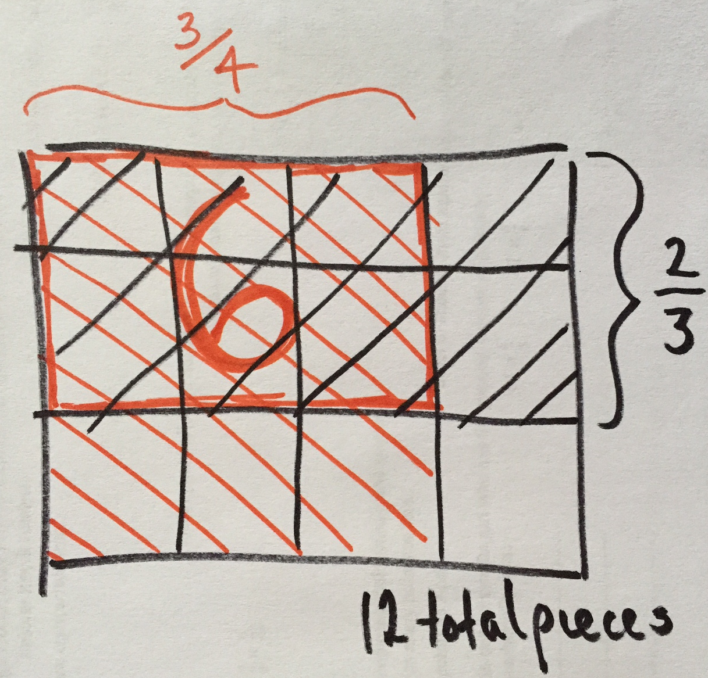

- One square mile is equal to 640 acres. What is the area, in acres, for the piece of land shown in the diagram below?
This problem builds on the relationship between multiplication and area. Students may see this as the sum of two products
(2 ½ x 3 + 2 ½ x ¾) or an instance of the distributive property (2 ½ x 3 ¾) by reconstructing the pieces.
Area = _6,000___ acres OR Equivalent
- What is the product of $2\frac{1}{2}×3\frac{3}{4}$ ?
$9\frac{3}{8}$ OR Equivalent
Students may recognize that this product has been solved in the previous question by the distributive property. Students who struggle with either #5 or #6 can be asked to look at the two problems together to compare what is being asked.
- Place points at $\frac{5}{2}$ and $\frac{1}{3} × \frac{5}{2}$ on the number line below.
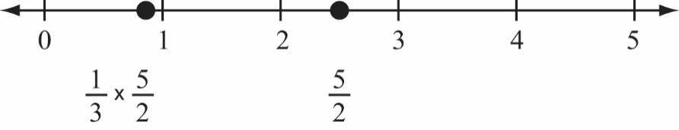
This problem leads to a general understanding of the multiplication of two fractions as $\frac{a}{b}×\frac{c}{d}=\frac{ac}{bd}$.

- Order the following numbers from greatest to least.
$\frac{5}{4}×15$ $\frac{4}{3}×10$ $\frac{2}{3}×15$ $\frac{3}{2}×10$
Greatest: $\frac{5}{4}×15$
The numbers in the expressions allow students to use reasoning about multiplication as scaling. Students should quickly see that 5/4 x 15 will be greater than 2/3 x 15 because the product will be more than 15 and the other will be less than 15. Similarly, students can reason that 3/2 x 10 = 1 ½ x 10 = 15.
Although some students may compute the product of each expression, teachers can use this problem to identify which students apply reasoning when approaching fraction scaling.
$\frac{3}{2}×10$
$\frac{4}{3}×10$
Least: $\frac{2}{3}×15$
- Tina is making $\frac{1}{4}$ pound hamburgers. Write an expression, using division that shows the number of hamburgers she can make with 9 pounds of hamburger meat.
$$9÷\frac{1}{4}$$

For more on the Major Work of the Grade, see achievethecore.org/emphases.

